## Nielsen Heuristics Evaluation Form (make as many copies as you need)

**1. What screen of the UI are you looking at (attach/paste a picture/screenshot):**

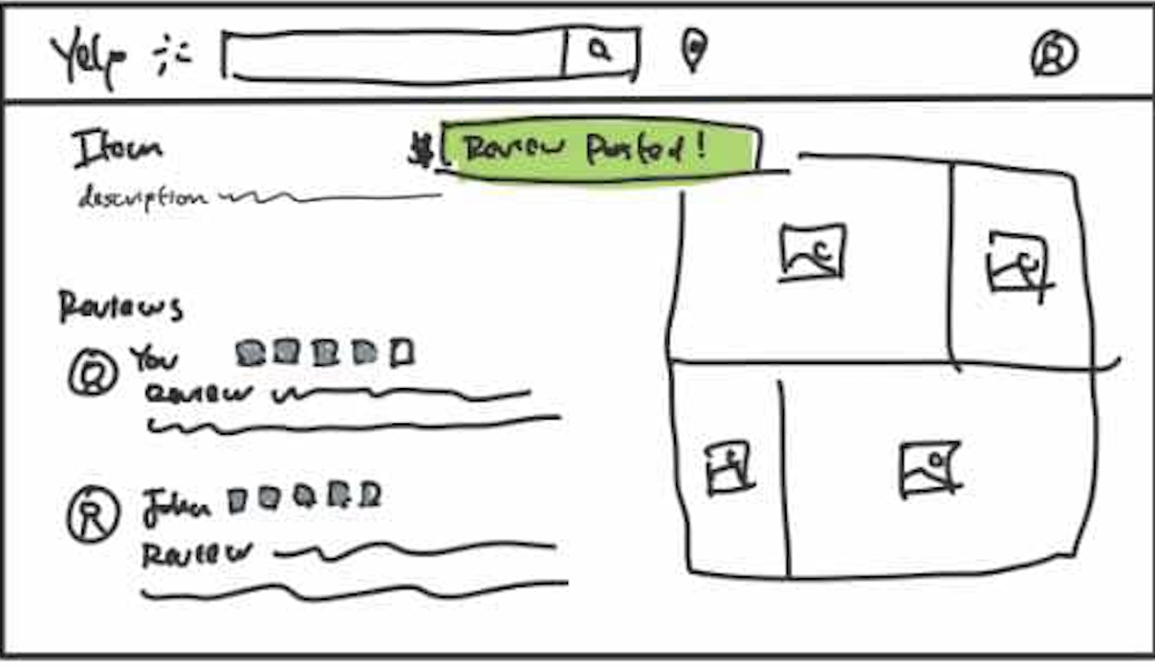

**2. Evaluate each heuristic below for this screen. Feel free to draw circles and arrows around the above screen shot.**

* Visibility of System Status:

**The "Review Posted!" confirmation provides immediate feedback after submitting a review, making it clear the action was successful. However, there is no indication of whether the review system is loading or processing other actions.**

* Match Between System and Real World

**The use of stars for ratings and text-based reviews mirrors real-world experiences, such as writing product or service reviews. The layout for displaying images also reflects common photo gallery designs.**

* User Control and Freedom

**The interface allows users to review items, but there is no visible "edit" or "delete" option for reviews already posted. This limits users' ability to correct mistakes or make changes.**

* Consistency and Standards

**The design follows established standards for review systems, such as a star rating system and a dedicated section for user feedback. However, the layout feels slightly inconsistent, with the photo grid appearing disconnected from the reviews and description.**

* Error Prevention

**The system does not seem to guide users to avoid errors, such as accidentally submitting a review. Adding a "preview" or "confirm" button could improve error prevention.**

* Recognition Rather Than Recall

**The layout supports recognition by visually displaying previously posted reviews and photos. Users can easily see their contributions without needing to recall specific details.**

* Flexibility and Efficiency of Use

**The interface is straightforward but lacks flexibility. For example, advanced users might benefit from sorting or filtering options for reviews (e.g., most helpful, most recent).**

* Aesthetic and Minimalist Design

**The design is clean and minimal, with essential elements such as reviews, ratings, and images prioritized. However, the green "Review Posted!" banner could be better integrated into the overall aesthetic, as it feels visually abrupt.**

* Help Users Recognize, Diagnose, and Recover from Errors

**There is no visible mechanism to diagnose or recover from errors (e.g., accidental review submission or formatting issues). A "Help" link or error message system would enhance this aspect.**

* Help and Documentation

**The design lacks any visible help or documentation features. Including tooltips or a "How to Review" guide would assist new users in navigating the review process.**